[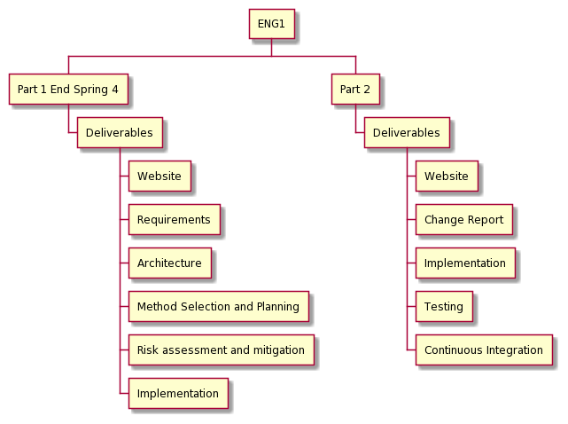](https://www.plantuml.com/plantuml/img/ZP2n3i8m34Htli9pjY8-00G8CO0gG69EmKeZKgV43lm-BYbiI8n-Fj-TF6UnIPuDJmoizvjgOWpKIg22DLtXs2TF3cQA3Qmm-0ScsmJa0HWuOyDUi0m7l6UVi4EISRr8brRN5ybfrEnGsgYs69JwI60rf0wMI6D66yytiCp8F5Yz5PqNx-nmK3JRhW_le0yhdQV_r5osbXngspuc-M6dx8GitqxBI3hac1cs9EXI4SwHhlgw5m00)